**ACTIVITY DIAGRAM**

**(AIR TICKET RESERVATION SYSTEM)**

1. Book Ticket Activity Diagram

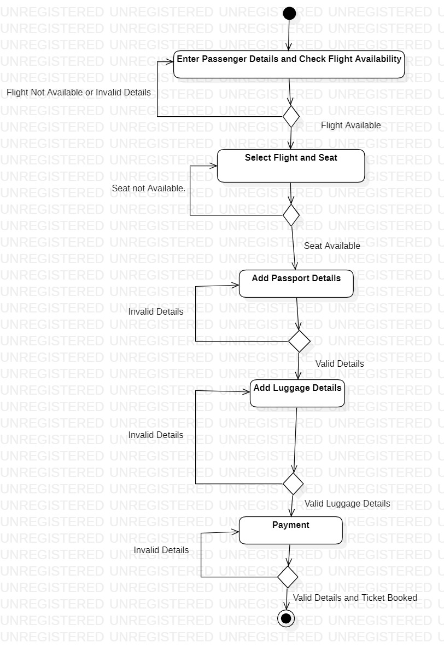

1. Register Activity Diagram

